Name: ____________________________________________________________________________________ Period: ___________________

The Backwards Study of a Predator-Prey Population

In this activity, you will use a graph to uncover a relationship between the Canadian lynx and the Arctic hare. Mathematical ecology requires the study of populations that interact and affect each other's population growth rates. In this study there are exactly two species, one of which -- the lynx -- eats the other -- the hare. Such pairs exist throughout nature:

* lions and gazelles,
* birds and insects,
* pandas and eucalyptus trees,
* Venus fly traps and flies.

To keep our model simple, we will make some assumptions that would be unrealistic in most of these predator-prey situations. Specifically, we will assume that

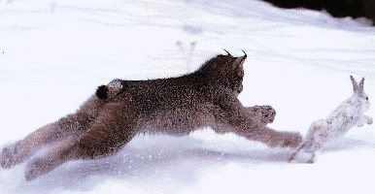
* the predator species is totally dependent on a single prey species as its only food supply,

* the prey species has an unlimited food supply, and

* there is no threat to the prey other than the specific predator.

Very few such "pure" predator-prey interactions have been observed in nature, but there is a classical set of data on a pair of interacting populations that come close: the Canadian lynx and snowshoe hare pelt-trading records of the Hudson Bay Company over almost a century. The following figure (adapted from Odum, Fundamentals of Ecology, Saunders, 1953) shows a plot of that data.

The early records of this study have been lost. It is your task to reconstruct the data and develop a reasonable hypothesis and set of procedures. When you are done be prepared to answer the question “What controls the populations of lynx and hares in Canada?”

This is the graph that has been found:

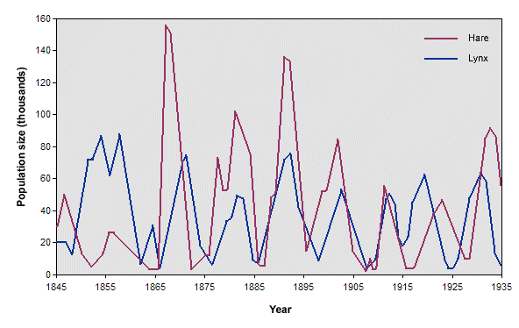
What was the data?

What might have been the procedures?

1.

2.

3.

4.

5.

What would have been a reasonable hypothesis?

What controls the populations of the lynx and the hares?

