Name: ____________________________________________________________________________________ Period: ___________________

Ecology: Hatching Brine Shrimp

Define and list examprles of each:
Abiotic Environmental Factors:

Biotic Environmental Factors:

Read through the following information about Brine Shrimp, their life cycle and their interactions with the environment. As you read, use two colored pencils to highlight both the abiotic and biotic factors in the Brine Shrimp’s environment. Use one color for biotic and a different color for abiotic:

Biotic Abiotic

The brine shrimp, Artemia, belongs to the phylum Arthropoda (joint-legged invertebrates), class Crustacea(shrimp, crab, lobster). There are several species of Artemia worldwide; Artemia franciscana is the species living in Great Salt Lake (and also in San Francisco Bay). Brine shrimp live in hypersaline lakes in which the salt content may be 25%, predators and competitors are few, and algal production is high. The life cycle of Artemia begins from a dormant cyst that contains an embryo in a suspended state of metabolism (known as diapauses or cryptobiosis). The cysts are very hardy and may remain viable for many years if kept dry. Water-temperature and salinity changes in Great Salt Lake occur in about February and cause the cysts to rehydrate and open to release the first growth stage, known as a nauplius larva. Depending on the water temperature, the larvae remain in this stage for about 12 hours, subsisting on yolk reserves before molting to the second nauplius stage, which feeds on small algal cells and detritus using hair-like structures on the antennae known as setae.

Although the cysts are very small (about 200 micrometers in diameter; 50 could fit on the head of a pin) at times they become so numerous that they form large red-brown streaks on the surface of the lake. Under optimum conditions of food supply and lack of stress from increasing salinity or decreasing dissolved oxygen, fertilized female shrimp may produce eggs that hatch soon after emerging from the ovisac to produce nauplius larvae, which is known as ovoviparous reproduction. If conditions are perfect, the female can live as long as 3 months and produce as many as 300 live nauplii or cysts every 4 days. However, the cold spring-time temperatures and variable food supply in Great Salt Lake usually limit the population to two or three generations per year.
The nauplii molt about 15 times before reaching adult size of about 10 millimeters in length. Adult male shrimp are easily identified by the large pair of "graspers" on the head end of the animal. These are modified antennae and are used to hold unto the female during mating. The population of Artemia franciscana in Great Salt Lake includes both males and females and reproduces sexually, but some species of Artemia exhibit parthenogenesis, a reproductive mode in which only females are present that give rise to young females in the absence of males. Adult shrimp feed primarily on phytoplankton (algae) suspended in the water but can also "graze" on benthic algae such as blue-greens or diatoms growing on the bottom of Great Salt Lake in shallow areas. They also may reprocess fecal pellets excreted earlier in the year when large numbers of phytoplankton present in their diet were incompletely processed. A recent study showed that the shrimp can graze on diatoms that colonize shrimp exoskeleton parts released from their many molts. As the food supply becomes exhausted, salinity increases, dissolved oxygen decreases, or a combination of these conditions occurs, the female shrimp switch from producing live young to producing cysts through oviparous reproduction. In Great Salt Lake, the adult shrimp typically die from lack of food or low temperature during December. Although, live brine shrimp have been observed in the lake at a water temperature of 3 degrees Celsius (37 degrees Fahrenheit), it is unlikely they can reproduce at that temperature. The cysts, which in Great Salt Lake are lighter than the lake water, float on the water surface where they may be harvested or may overwinter to form the source of shrimp for the following year. Brine shrimp are also called "Sea Monkey"s and are raised in aquariums for their entertainment value.
In the table below, use your highlighting to list all of the biotic and abiotic factors in the Brine Shrimp environment:
Abiotic Factors | Biotic Factors

Now, you are going to be using your knowledge to hatch some of your very own Brine Shrimp from the Great Salt Lake. You will have two sets of cysts – one will be a control group and the other will be an experimental group.
In general, what is a control group? What is the purpose of a control group?

In general, what is an experimental group? Use the terms independent and dependent variable in your definition.

Of the factors you listed at the beginning of the lab, which one will your group be manipulating?

Is your factor biotic or abiotic? How do you know?

Explain how you will manipulate that factor in your experiment.

Materials:

Brine Shrimp Eggs
Small watercolor brush
Clear double-sided tape
Transparency Sheets
Microscopes
Petri Dishes
Salt water solution
Small pipets
Marker
Scissors
Magnifying glass
Single hole punch

List any other materials you may need for your experimental group:

Write a hypothesis (if…then…) about your experiment:

Procedure:
First, you will assemble the petri dish for your control group. Follow the instructions below:

- Cut 1” length of double-sided tape and adhere it smoothly to the inside bottom of a petri dish. Do not wrinkle the tape or trap an air bubble under it.

- Cut a piece of transparency film the same size as or slightly larger than the tape.

- Use a hole punch to make a hole near the center of the piece of film.

- Stick the film over the strip of tape so the tape is completely covered except for the hole (this small circle provides a sticky surface to receive the eggs).

- Touch the tip of a paintbrush lightly into a container of dried brine shrimp eggs so that you pick up only a few eggs with the bristles. If too many eggs attach, tap the brush against the lip of the container to get rid of the excess eggs.

- Drag the tip of the brush back and forth across the exposed sticky tape in the bottom of the petri dish. Repeat if needed until you estimate that there are between 20 and 50 eggs stuck to the tape.

7. Count the eggs and record the initial number in the data table.

8. Add 30 mL of salt solution to the dish and cover it with the lid.

Your experimental group will have a slightly different procedure depending on the variable you choose and how you are going to test it. Use the same design as the control but just change ONE FACTOR as indicated in your hypothesis. Write your additions below:

Same as 1 through 8 above.

9.

10.
Now, place your petri dishes along the edge of the classroom and make sure all conditions are right for your experimental group. Put a label by your petri dishes so you know which ones are yours.

Data:

Control Group Data
 | Initial Number of Eggs | Number Hatched | % Hatched
Following Class

Experimental Group Data
 |  |  | Initial Number of Eggs | Number Hatched | % Hatched
Following Class

Graph your data. Be sure to only graph the % Hatched, and not the specific number. Include: title, scaled axes, labeled axes, units, a key (if necessary).

Analysis:

Did the variable you changed in your experimental group help or hinder your brine shrimp eggs?

How did you set up your experiment so that you could tell the differences between the two petri dishes was due ONLY to your changed factor? (Hint: control variables).

What is the scientific name for the changed factor between groups in an experiment?

Discuss the experiment with other groups and find out what factors they changed in their experiment. Were all of factors biotic? Do only biotic factors affect an organism?

Describe the experiment of a group that tested a biotic factor:

Variable:

How did they change it:

Result:

Describe the experiment of a group that tested an abiotic factor:

Variable:

How did they change it:

Result:

Application:

The following organisms are all found in the Great Salt Lake ecosystem.

Brine Shrimp

At a maximum length of just over 1 cm (0.4 inch), brine shrimp are the largest animals that live in Great Salt Lake. Despite their small size, they are an important part of the lake's ecosystem. Each year millions of birds fatten up on brine shrimp as they prepare nest or migrate around the globe. The food that keeps brine shrimp healthiest is the microscopic algae Dunaliella veridis. Dunaliella are soft and nutritious, and they are usually plentiful early in the spring when brine shrimp hatch. But brine shrimp eat lots of other things too. They are passive filter feeders, which means they collect whatever is in the water and sweep it into their mouths. They take in anything and everything they can swallow, including cyanobacteria, archaea, bits of detritus and diatoms.

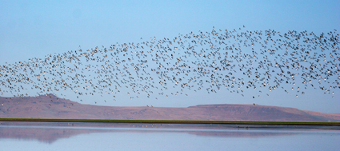
Birds

The sheer numbers of birds that stop to fill up at Great Salt Lake can be staggering. More than half a million Wilson's phalaropes, amounting to more than one third of the world's population, have been counted on the lake in a single day. While they're here they gorge themselves on brine shrimp and brine flies, nearly doubling their body weight before beginning a 5,400 mile migration.
As many as 1.7 million Eared Grebes—nearly half of the North American population—come to Great Salt Lake in the early fall to grow new feathers (molt). Great Salt Lake is a safe place for them to spend this vulnerable time during which they cannot fly. Predators are rare, and they have access to huge numbers of brine shrimp, which supply them with the protein and calories they need to grow new feathers as quickly as possible. With full bellies and a new set of feathers, they are well prepared for their fall migration.

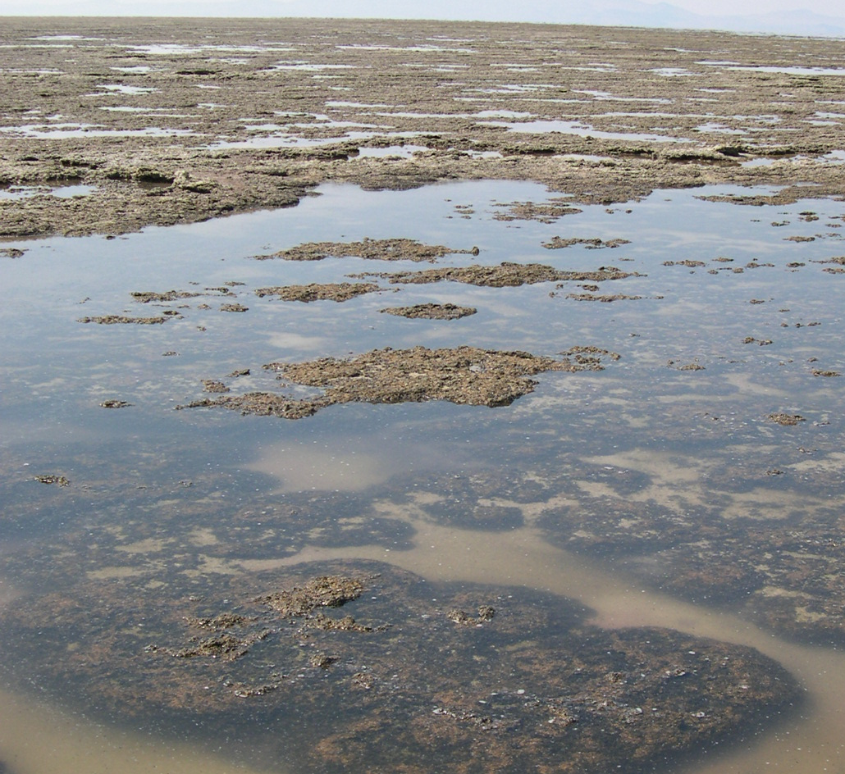
Bottom-dwelling Microbes

The shallow bottom of Great Salt Lake supports a microbial carpet that harness the sun's energy through the process of photosynthesis. This carpet is made up of a community of microbes, including several types of cyanobacteria (also known as blue-green algae), algae and other organisms. The bottom-dwelling microbes are often referred to as benthic algae.
Free-floating algae such as Dunaliella that live higher in the water column typically bloom early in the year, blocking sunlight from reaching the lake bottom. Later in the spring, brine shrimp begin to hatch and quickly graze down the Dunaliella population. This increases the clarity of the water, allowing sunlight to reach the lake bottom, and providing energy for the bottom-dwelling community to bloom. Cyanobacteria are a source of both food and oxygen for developing brine fly larvae, which become plentiful during the summer and early fall. Some of the cyanobacteria that colonize the lake bottom cluster together into thick gooey masses. They are an important food source for brine fly larvae, and they provide support and protection for brine fly pupae.

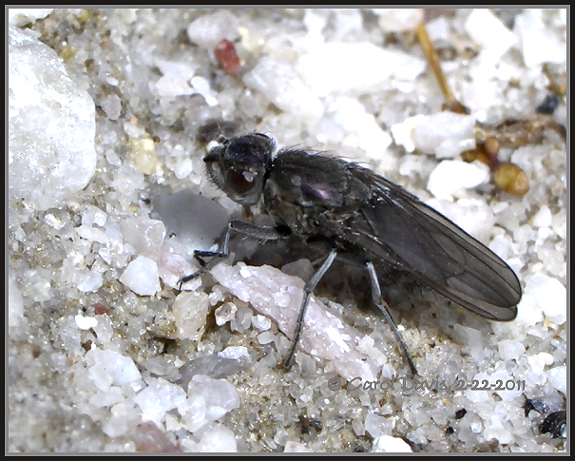
Brine Files

Brine flies live most of their lives underwater. They eat mostly cyanobacteria, but their diet also includes other types of bacteria, bottom-dwelling algae, diatoms, and detritus. They prefer to live in muddy areas or on bioherms rather than in sandy areas. After one to a few weeks (depending on the water temperature) the adults emerge from their pupal casing and float to the surface. Adults live for only a few days, just long enough to mate and lay eggs. If food is plentiful and temperatures remain high, brine flies can complete two life cycles in one season. After the adult brine flies hatch, pupal casings are blown about by the wind. The brown casings pile up in often miles-long masses along the shoreline. Decomposers such as bacteria and fungi break down the pupal casings and return their nutrients to the food web.

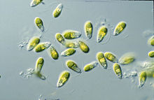
Free-floating Microbes

Many different microbes, including several types of algae, bacteria and archaea, float in the water of Great Salt Lake. This community of free-floating microbes is often referred to as plankton, phytoplankton, or a pelagic community. Free-floating microbes harvest energy from the sun through the process of photosynthesis. In the south arm of Great Salt Lake, these organisms supply oxygen and food for the brine shrimp population. The algae Dunaliella veridis are the brine shrimp's favorite food. The success of Dunaliella largely determines to what extent the brine shrimp population thrives, and brine shrimp tend to thrive in areas where the Dunaliella population is greatest.

Use the information you just read to draw a food web. You should have at least one organism mentioned in the descriptions, but not specifically listed as part of your food web. Also label the type of energy that is at each level (chemical, solar, mechanical, etc.).

Identify which organisms in your food web are:
(Certain organisms may belong to more than one group)

Producers:

Primary Consumers:

Secondary Consumers:

Tertiary Consumers:

Decomposers:

Which group do you think has the greatest population of organisms? Which group do you think has the least? Why?

Choose one of the organisms in your food web: ______________________________________________________

What would happen if that organism were removed from the ecosystem? List at least 5 direct effects in complete sentences. If possible, identify the order that your consequences would occur in.

Would abiotic factors in the ecosystem be affected by the removal of this organism, or would only biotic factors be affected? Explain your answer and give an example if possible.

Explain pH levels.

Limiting factors limit the size of a population. Explain 3 factors that could possibly limit the population of the brine shrimp.

Draw an energy pyramid that represents this ecosystem. Place all of the organisms that are in the picture above in the energy pyramid. Label the amount of energy expected at each level if you started with 100,000 calories of energy at the producer level.

Explain 2 reasons why there is not as much energy available to top levels of the pyramid as there is available to base levels.

Why must energy constantly be added to the environment?

Choose 2 organisms interacting with each other that are shown in this ecosystem. Compare the amount of energy used obtaining the food to the amount of energy gained from the food. Which is greatest? Which is the least? Why is this important?

List 2 reasons that might cause one of the organisms you chose in question 9 to use more energy than usual. What are 2 things that might cause that organism to use less energy?

