Name:________________________________________________________________________Period:_______
Cell Theory
What are the 3 parts of the Cell Theory?
1.

2.

3.
Draw lines to match the scientist to their discovery:
4. Anton Van Leeuwenhook | Discovered that all animals were made of cells with his colleague Schleiden
5. Robert Hooke | Proposed that cells come from other cells, known as the Father of Medicine
6. Matthais Schleiden | Developed a compound miscroscope and used it to observe single celled organisms.
7. Theodor Schwann | Discovered that all plants were made of cells with his colleague Schwann
8. Rudolf Virchow | First discovered the cell, named that after his room in the monastery he lived in.

9. How did these scientists take what they learn and build onto previous discoveries?

10. How have further advancements in technology played a role in our understanding of the cell?

11. One of the most unifying principles in Biology is homeostasis. Define homeostasis and give a unique example of how the human body will attempt to achieve this:

12. Fill in the blanks:
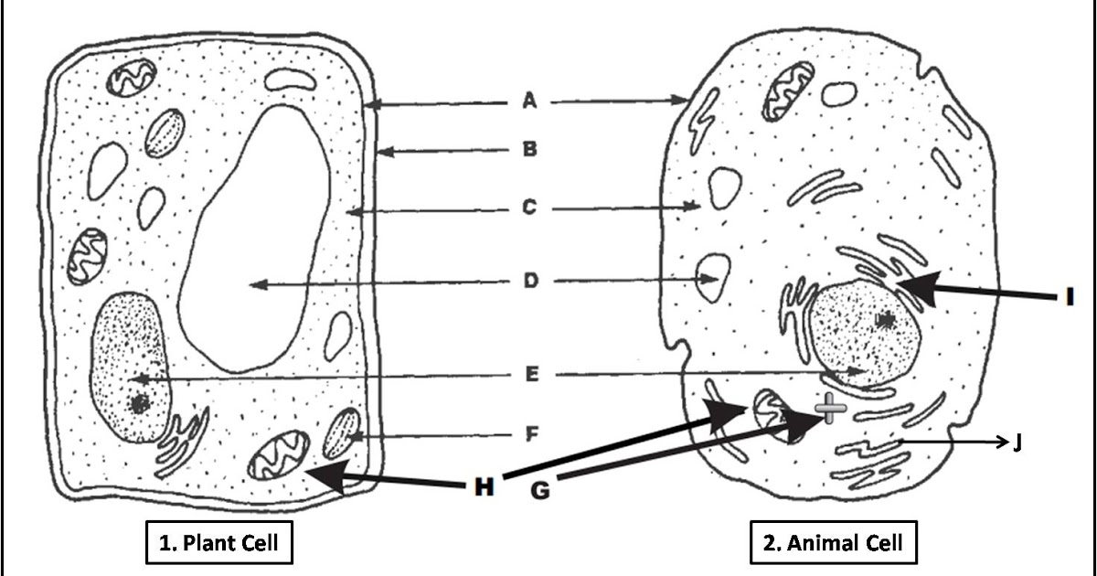

13. Using Latin roots, decipher and differentiate the following two words:
Pro-kary-ote: | Eu-kary-ote:
14. What kind of organisms might have prokaryotic cells?

15. What kind of organisms might have eukaryotic cells?

Organelles: look through the textbook (196-204) or use a reputable online source
Organelle | Structure (Draw picture) | Function (how does it work) | Plant or Animal
16. Cell Wall
17. Cell Membrane
18. Vacuole
19. Cytoplasm/
Cytoskeleton
20. Ribosome
21. Mitochondria
22. Chloroplast
23. Smooth Endoplasmic Reticulum
24. Rough Endoplasmic Reticulum
25. Lysosome
26. Nucleus
27. Golgi Apparatus
28. How do the functions of one rely on the function of another?

29. Create an analogy in your notebook of a system with parts like the organelles and how they work together.

30. Using the knowledge you have just gained about Cell Theory and Organelles, create either a graphic organizer showing the information and how it relates to one another or write a poem, song or short story about the cell.

1.-3. Cell Theory- http://www.kidsbiology.com/biology_basics/cells_tissues_organs/cell_history_discovery4.php

11. Homeostasis- https://www.thoughtco.com/homeostasis-defined-373304

4. Van Leeunwehoek- http://www.history-of-the-microscope.org/anton-van-leeuwenhoek-microscope-history.php

5. Robert Hooke- begin reading below the two pictures
http://www.ucmp.berkeley.edu/history/hooke.html

6. Matthais Schleiden- https://www.britannica.com/biography/Matthias-Jacob-Schleiden

7. Theodor Schwann- http://fig.cox.miami.edu/~cmallery/150/unity/cell.text.htm

8. Rudolf Virchow- https://www.famousscientists.org/rudolf-virchow/

Scientists Quizlet- https://quizlet.com/232721262/cell-theory-flash-cards/

Organelles Quizlet- https://quizlet.com/414811/cell-organelles-flash-cards/

12. Picture of Organelles http://thegreatestgarden.com/wp-content/uploads/animal-and-plant-cells-are-prokaryotic-or-eukaryotic.png

