Station #1- Atoms
Look at the periodic table on the garage door. Using white boards, draw Carbon. Discuss with your table how many electrons are on each ring, what the charges of protons, neutrons and electrons are, and the difference between atomic number and atomic mass. Then draw Sulfur.

Station #2- Molecules: Covalent vs. Ionic

Use whiteboards:

Try to draw a molecule of table salt which is NaCl. This is an ionic bond because the Na(sodium) has one extra electron on its outside shell and it gives it away to fill the one empty spot on Chlorine’s outside shell.

Try to draw a water molecule. Remember this has two hydrogens and one oxygen. The two hydrogen can fill in the empty spots on the oxygen molecule but they need to share electron pairs in order to be stable. This is a covalent bond which is stronger than ionic.

Station #3- CHNOPS
The acronym CHNOPS, which stands for carbon, hydrogen, nitrogen, oxygen, phosphorus, sulfur, represents the six most important chemical elements whose covalent combinations make up most biological molecules on Earth. Review your flashcards and find cool facts about each.

Station #4-Macromolecules
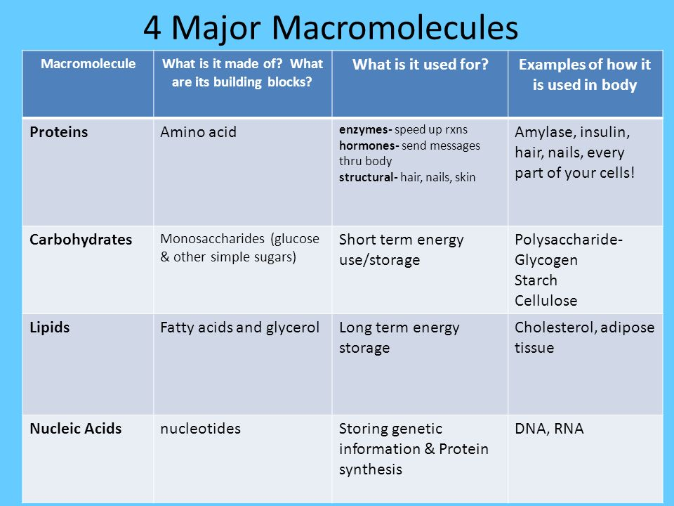
Review this material and identify which structure belongs to which macromolecule.
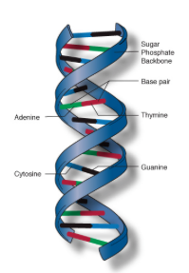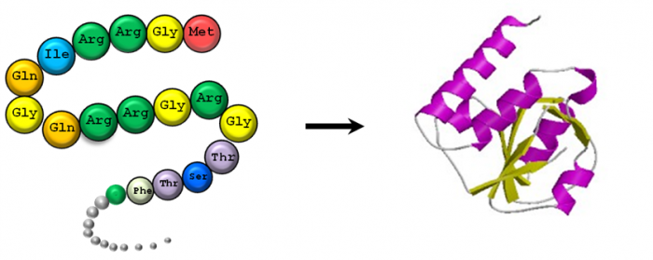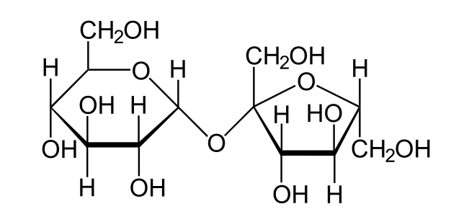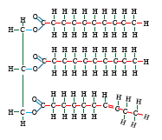
Turn and talk about how each of these functions are important for life.
Station #5-Water properties
Cohesion, Adhesion, Surface Tension, Polarity
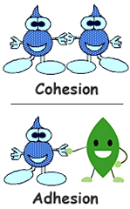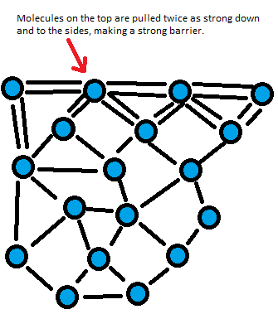
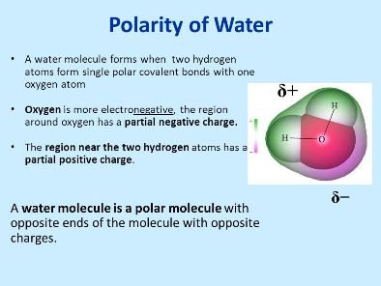
Turn and talk about how each of these properties are helpful to life on this planet.
Station #6-Water properties
High specific heat, Density, Capillary Action, Solvent
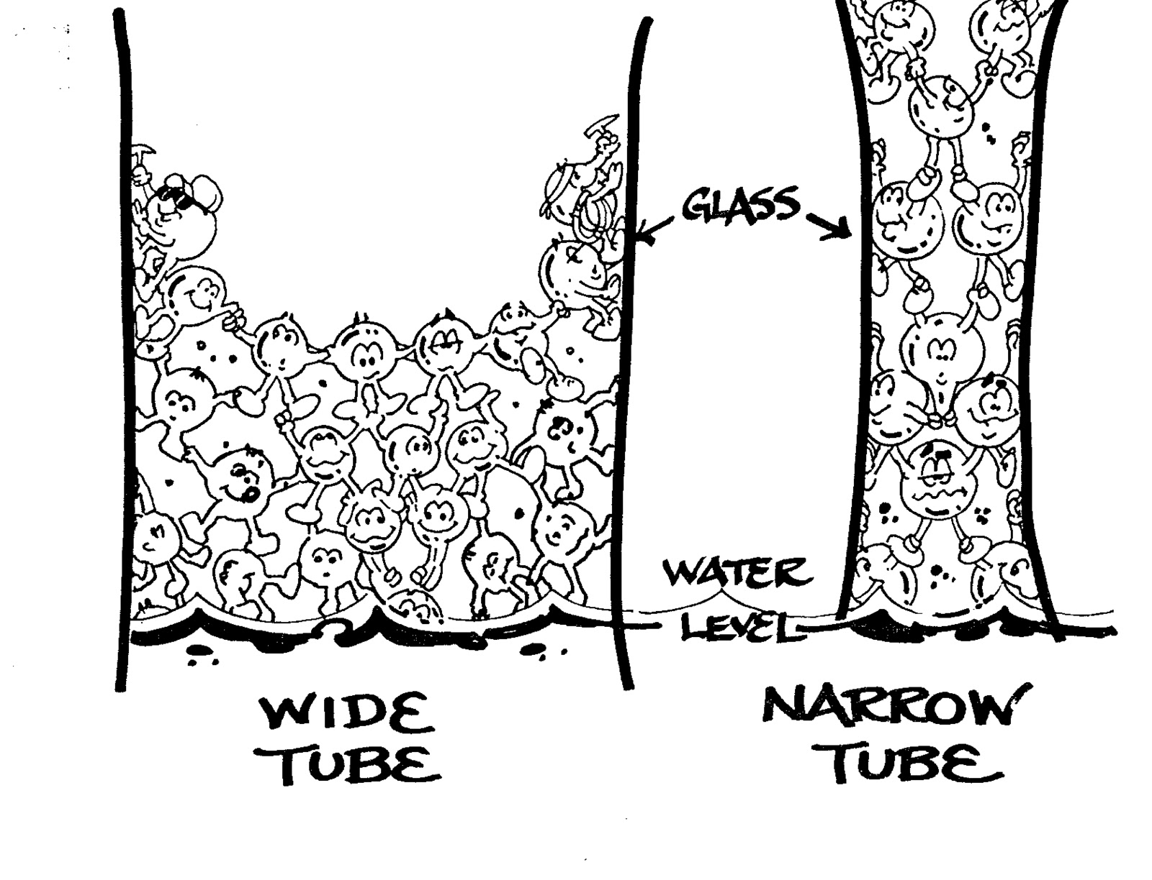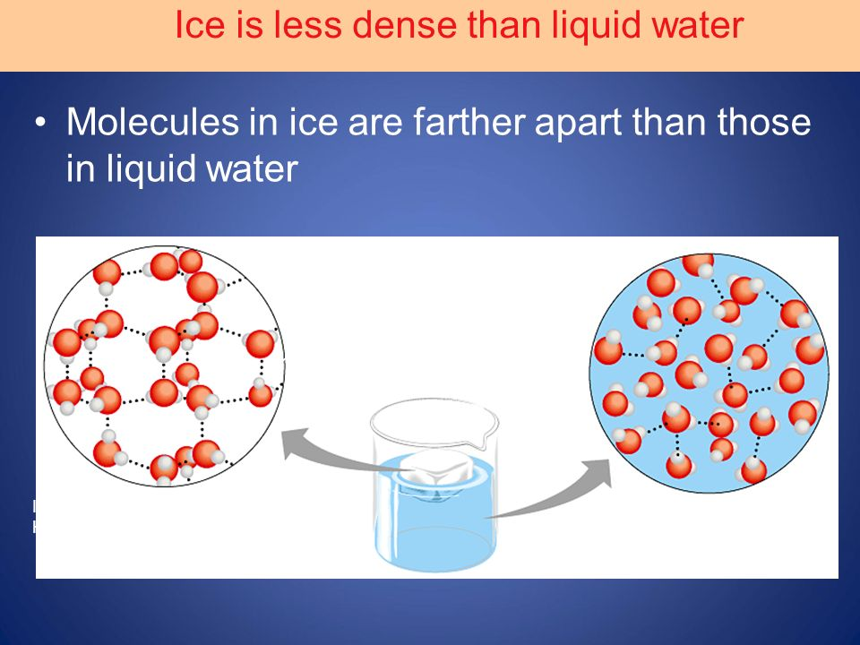
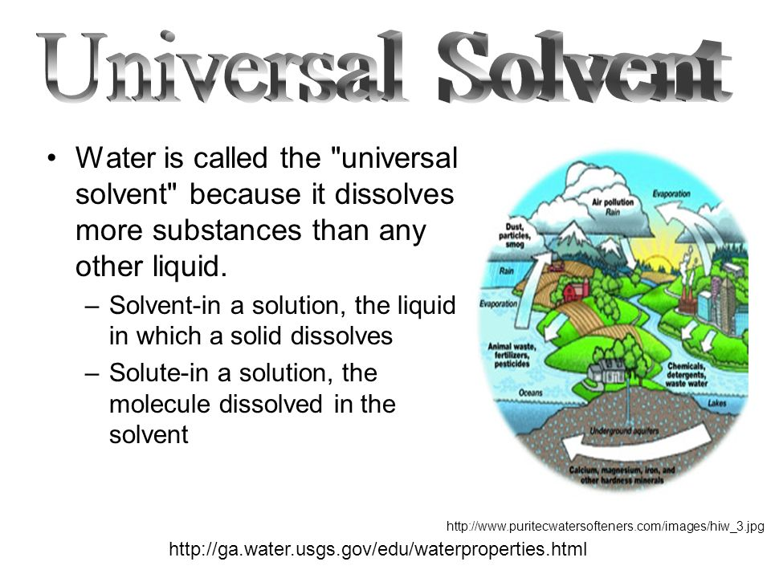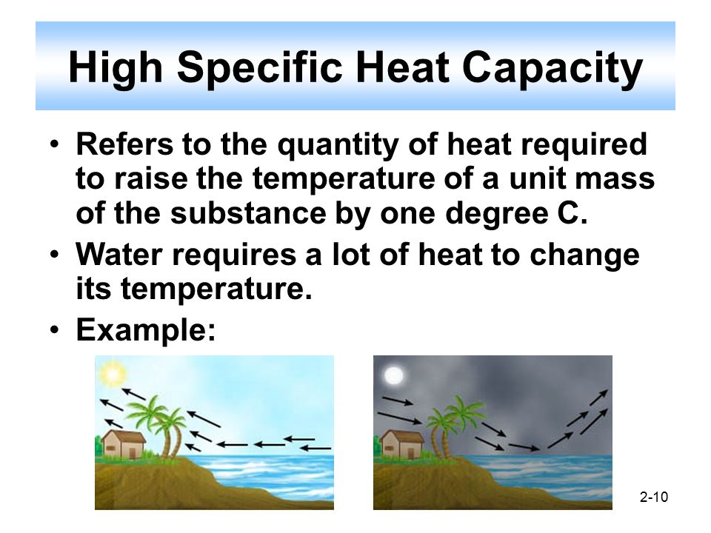

Turn and talk about how each of these properties are helpful to life on this planet.
Station #7 Enzymes
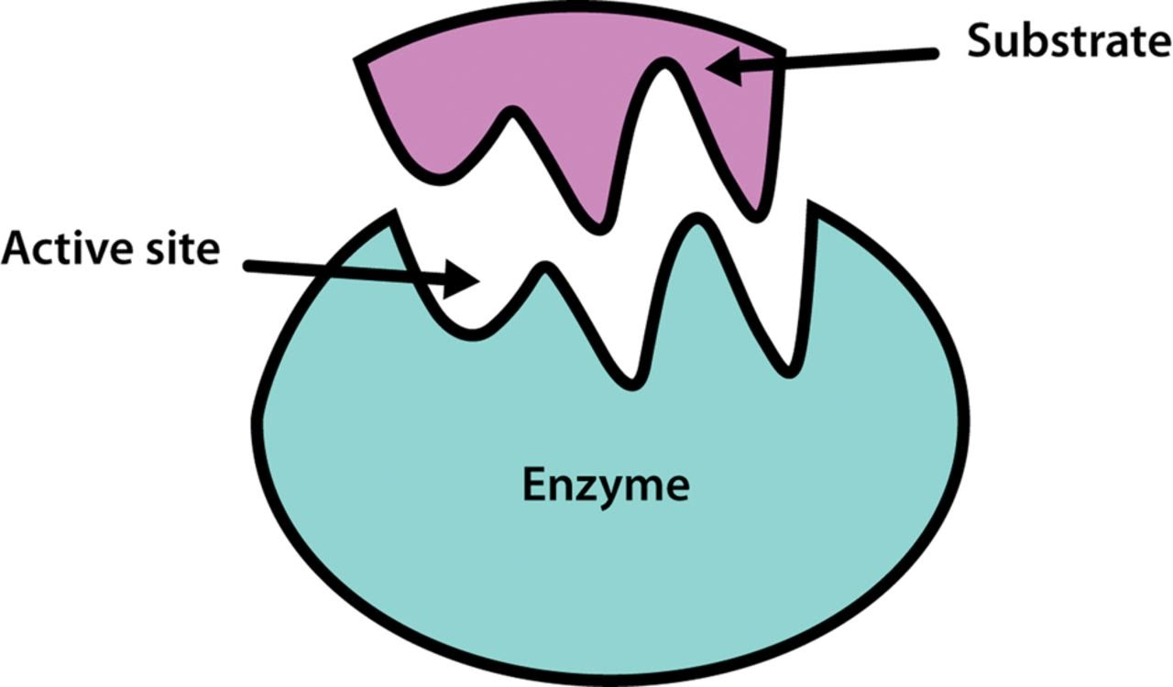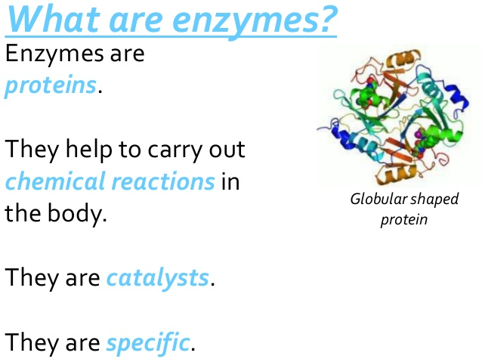

What are the 3 factors that can speed up or slow down a reaction? Why?

Station #8 Photosynthesis and Cellular Respiration
