Name________________________________________________________________________Period__________

**Evolution: Do I Know The Answers?**

1. Which of the following statements is true about this cladogram?



a. Beyond any doubt, it shows the exact evolutionary relationships between these species.

b. Leopards have more similar DNA to lampreys than turtles.

c. Turtles are more closely related to salamanders than to tuna.

d. All of the other species evolved from lancelets.

2. In the scientific name of a dog, *Canis lupis*, the name *Canis* designates what level of classification?

3. Which level of classification contains species that are most dissimilar from each other?

4. According to Darwin’s theory of natural selection, the individuals that tend to survive are those that have

|  |  |
| --- | --- |
| a. | characteristics their parents acquired by use and disuse. |
| b. | characteristics that plant and animal breeders value. |
| c. | the greatest number of offspring. |
| d. | variations best suited to the environment. |

5. When a farmer breeds only his or her best livestock, the process involved is called:

6. A factor that is necessary for the formation of a new species is:

7. If all bunnies were exactly identical genetically, would natural

selection cause bunnies to evolve?

8. A particular population of mice contains both black and white mice. These mice live on black rocks. What might happen to this mouse population after many generations?

9. Jean Baptiste Lamarck was one of the first people to propose that species change over time. In what way or ways was he wrong?

10. The bones of a whale flipper are similar to the bones of a bat wing. What might a biologist conclude after looking at this picture?

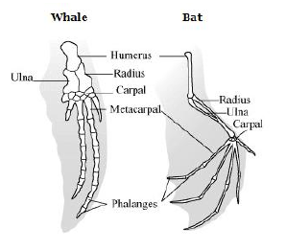

11. European rabbits were introduced to Australia in 1859. The rabbits reproduced rapidly in their new habitat, displaced other animals, and overgrazed vegetation. In an attempt to reduce the rabbit population, a virus was introduced in 1951. This virus is usually deadly to European rabbits.

When the virus was first introduced, the rabbits died in large numbers, but the death rate decreased over time. What would best explain the decrease in the rabbit death rate?

12. Farmers breed only tomato plants that will produce the biggest and most abundant crop. This is an example of:

13. In a mouse population inhabiting a grassland area, a mutation occurs that results in a new coat color allele. What would be a factor that would have an effect on whether the new coat color would become more common in the mouse population?

14. Which of the following would be the MOST convincing evidence that two species evolved from the same species (in other words, that both species have a common ancestor)?

a. They live in the same area

b. They reproduce at the same time

c. They have similar DNA

d. They have similar body movements

15. The picture below shows a turtle and a chicken embryo.

What does this tell you about the chicken and the turtle?

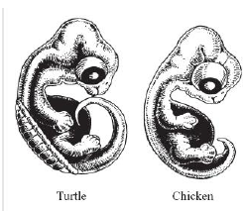

16. Give 3 examples of a vestigial structure.

17. This picture shows the pelvic and leg bones of a baleen whale, as well as a whale species that has been extinct for millions of years.

The presence of these bones in the baleen whale and the extinct whale provides evidence of what?

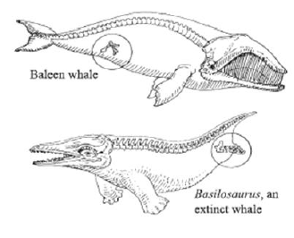

Two species of finches live on different parts of an island. One species lives in rainy conditions, the other species in drought conditions. Use the graph to answer #18 and #19.

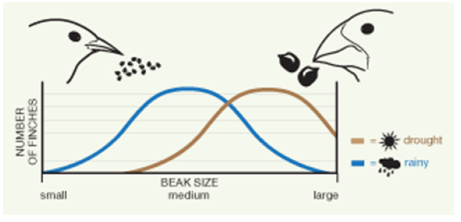

18. What would be a good conclusion one can draw from this graph?

19. What can we **infer** about the seeds and nuts on the island?

For the next 4 questions match the scientist with the idea he proposed. Answers may be used more than once

20. Stated that there is a struggle for existence within a species and published this idea, prompting Darwin to publish his book.

A. Darwin

B. Lamarck

C. Wallace

21. Used Galapogos finches as an example of species that descended from a common ancestor finch.

22. Proposed the idea of “use and disuse.” Giraffes who stretch necks to reach leaves will get longer necks and pass the trait on to offspring.

23. Proposed the idea of Natural Selection in his book “On the Origin of Species.”

24. Which of the following meanings of "theory" best fits the meaning scientists use when they refer to "Cell Theory or "Theory of Evolution"?

a. possible but untested ideas

b. An idea someone has about how or when or why something happens

c. An impractical idea

d. A fact or bit of evidence available to explain something

e. A set of tested positions, explanations and concepts that explain known data and predict additional phenomena

25. Which type of reproductive isolation best describes the speciation of two frog populations separated by a mountain range?

26. Mating two dogs of the same breed to get a certain hair color is an example of

27. Darwin's and Wallace's observations led them each to develop a hypothesis to explain the evidences that they had observed over time, these hypotheses have been supported by scientists studying many different organisms. These many facts, inferences, and tested hypotheses make up the Theory of

Evolution. Why is this known as the Theory of Evolution?

28. What is the major ecological reason that biodiversity is important in nature?

29. Scientists believe that the more primitive fossils in deeper rock layers are older than those found in layers closer to the surface. Which of the following statements best explains how scientists can come to this conclusion?

a. Scientists assume that older fossils had more time in which to sink deeper into the sediments

b. Scientists assume that in the past, layers of sediment were sequentially deposited on older layers using the same processes observed today

c. Scientists assume that more primitive organisms lacked advanced means of locomotion in which to escape being buried in sediments and were therefore buried first

d. Scientists assume that older, more primitive fossils were burrowing animals that dug deeper into the sediment layers

30. Genetic diversity is often provided by what processes?

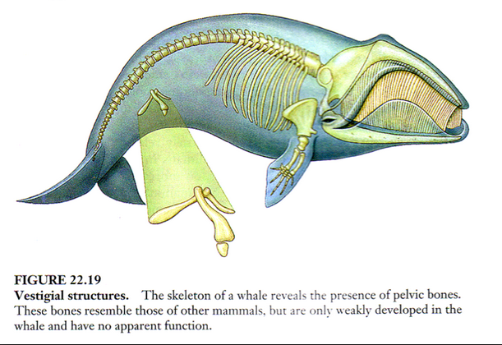

31. What is a good **inference** you can make based on the picture above?

**Use the following fictional classification key to answer questions 32-33.**

1. A. The tree has leaves…………………………………………………………………...go to 2

B. The tree has needles………………………………………………………………….go to 3

1. A. The leaves are white in the spring...………………………………………………….Frin

B. The leaves are green in the spring...………………………………………………….go to 5

1. A. The needles are single………………………………………………………………...Spruce

B. The needles are in bundles ……..…………………………………………………….go to 4

1. A. The bark of the tree is rough………………………………………………………….Ponderosa

B. The bark of the tree is smooth………………………………………………………...Pinyon

5. A. The leaves have parallel veins………………………………………………………...Yucca

B. The leaves do not have parallel veins…………………………………………………go to 6

6. A. The leaf has a smooth edge……………………………………………………………Apix

B. The leaf has a notched edge……………………………………………………………Birch

32. Which two trees below have leaves rather than needles?

a. Yucca and Birch

b. Ponderosa and Pinyon

c. Pinyon and Apix

d. Spruce and Frin

33. What is the biggest difference between the Spruce and the Ponderosa?

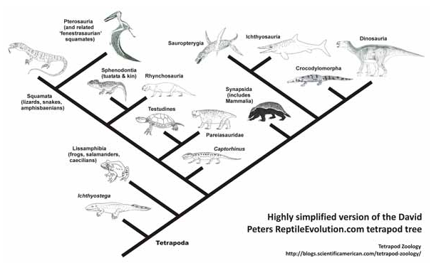

34. Based on the above diagram, which reptiles have the closest evolutionary relationship?

a. Squamata and Crocodylmorpha

b. Lissamphibia and Ichthyosauria

c. Sphenodontia and Rhynchosauria

d. Lissamphibia and Synapsida

35. What are the three conditions necessary for natural selection?

36. When two species only breed after singing a specific song this is known as: