Name__________________________________________________________________________________Period________________
Fish Classification

Fish # | Key pathway | Fish name
1
2
3
4
5
6
7
8
9
10
11
12
13
14
15
16
17

Dichotomous Key to Some North American Freshwater Fish

1a. Body more or less covered with scales 2
b. Scales lacking or too small to be seen 12

2a. Dorsal fin single 3
b. Dorsal fins two or more, joined or separated (if ½ fin spiny and ½ fin smooth, then these are 2 joined fins) 6

3a. Body more than four times as long as broad (top to bottom, not including fins); front edge of dorsal fin far back on body; mouth large, hinge of jaw behind the eye 4
b. Body less than four times as long as broad; front edge of dorsal fin about midway between head and tail; mouth not large, hinge of jaw in front of eye 5

4a. Dark lines forming netted design on body; fins not spotted Pickerel
b. Body covered with yellow spots; fins spotted Northern pike

5a. Mouth turned downward; barbels absent; dorsal fin not elongated White sucker
b. Mouth not turned downward; barbels present; dorsal fin elongated Carp

6a. Two dorsal fins completely separated, the anterior spiny and the posterior soft 7
b. Two dorsal fins united, forming an anterior spiny portion and a posterior soft portion 8

7a. Top of head concave, forming a hump in front of dorsal fin; dark vertical bars on body Yellow perch
b. Top of head not concave, body sloping to dorsal fin and not forming a hump; dark blotches on body Wall-eyed pike

8a. Body (including caudal fin) more than three times as long as broad (top to bottom, not including fins) 9
b. Body (including caudal fin) less than three times as long as broad (top to bottom, not including fins) 10

9a. Notch between spiny and soft dorsal fin deep, nearly separating the two fins Large-mouth black bass
b. Notch between spiny and soft dorsal fin shallow, not nearly separating the two fins Small-mouth black bass

10a. Mouth large, hinge below or behind the eye 11
b. Mouth small, hinge in front of the eye Bluegill

11a. Five to seven spines in dorsal fin; dark spots forming broad vertical bars on sides White crappie
b. Ten or more spines in dorsal fin; sides flecked with dark spots Rock bass (Redeye)

12a. Body elongated and snakelike; dorsal, caudal, and anal fins continuous Eel
b. Body not elongated and snakelike; dorsal, caudal, and anal fins separate; adipose fin present 13

13a. Barbels growing from lips and top of head; head large and broad 14
b. Barbels lacking; head not large and broad 16

14a. Caudal fin deeply forked; head tapering 15
b. Caudal fin rounded or slightly indented but not forked; head blunt Bullhead catfish

15a. Dorsal fin rounded at top; body silvery, speckled with black markings Channel catfish
b. Dorsal fin long and pointed at top; body bluish-gray without speckles Blue catfish

16a. Caudal fin forked; back not mottled and with few spots; first dorsal fin not spotted or mottled Atlantic salmon
b. Caudal fin square or slightly indented; back mottled or spotted; first dorsal fin spotted or mottled 17

17a. Back and caudal fin spotted; broad horizontal band along sides Rainbow trout
b. Back mottled with dark lines; caudal fin not spotted; ventral fins edged with white Brook trout

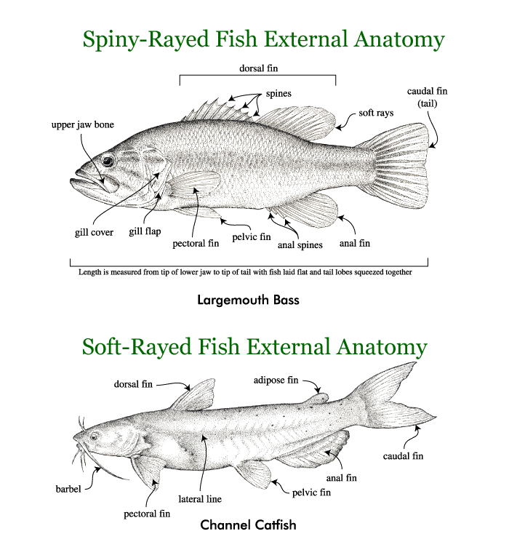
hinge of jaw
2 dorsal fins

