Flower Dissection
Background information:
Many plants (angiosperms) contain flowers where the sex cells are contained for the plant’s reproduction. The stamen is the male organ for reproduction and is composed of the anther and filament (or stalk). At its tip is the anther, the organ that produces the pollen. Pollen is composed of fine grains that contain the male sex cells. The pistil is the female organ; its parts include the stigma, style, and ovary. During pollination, male pollen lands on the stigma, germinates and the sperm cells travel down the style, and fertilize the eggs in the ovary. The fertilized eggs develop into seeds. Sepals are the leaf-like parts under the petals. They are usually green and photosynthetic (able to produce food with the sun’s energy). Petals can be all colors, shapes, and smells which serve to attract pollinators.
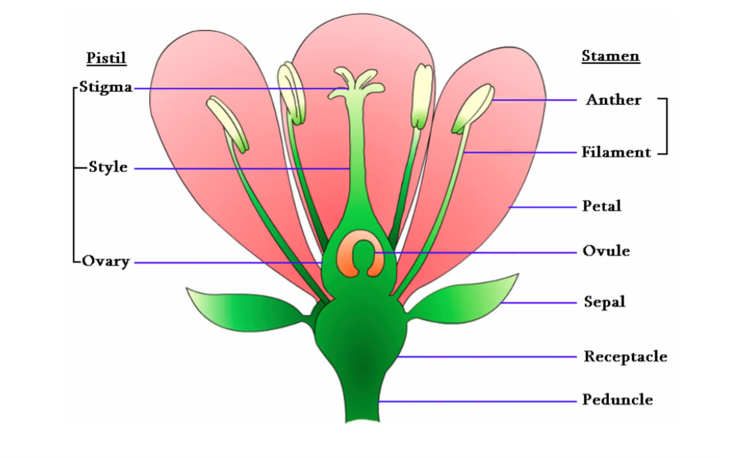
Procedure
- Review the parts of the flower and their functions on the Flower Anatomy worksheet that we went over in class. Label a page in your notebook, flower dissection.

- Dissect your flower carefully. Remove the parts and set aside. You will tape and label all the parts as your last step.
  - Observe the sepals and petals. Sepals are usually green, leaf like parts at the base of the flower. Sepals provide protection to the bud. Petals are usually the brightly colored parts of a flower. Petals protect the delicate structures inside the flower and may also attract insects. The sepal and petals are not directly involved in reproduction and many flowers lack them.

  - Carefully remove a sepal (if you have one, not all flowers do) and all the petals from the flower by holding the flower stem and gently pulling the sepal and petals away and off.

  - Take a look at the stamen. This is the stalk-like structure with caps found on the inside of the petals, or still attached to the stem. All parts that make up the stamen are associated with a flower’s male reproductive system. The stalk portion of a stamen is the filament. It supports the anther. The anther produces pollen grains that contain plant sperm. Carefully remove a stamen.

  - Now focus on the pistil. The pistil is a slender stalk like structure with a round base connected to the stem. All parts that make up the pistil are associated with a flower’s female reproductive system. A detailed study of the pistil reveals that it is composed of three parts. The stigma is the top portion of the pistil. It is usually sticky. The stigma is the collecting place for pollen grains. The stalk of the pistil is the style. The base of the pistil is the ovary, which may be partly hidden from view by the sepals. The ovary contains ovules. The ovules are the eggs of plants. Very, very carefully cut the pistil in half long ways with the razor blade. Cut on the Petri dish, NOT the table top.

- Make wet-mount slides of pollen grains (high power) and a thin sliced section of the ovary (low power). Make a labeled drawing of each (both the size of a petri dish). Draw what you see in the microscope in your notebook. Be sure to include the magnification.

- Make a cross section cut of the stem and place it in the petri dish to observe under the microscope. Make a drawing in your notebook of your observation and label the 4 plant tissues and their locations on the stem that we discussed in class.

- Tape one sepal, one petal, one stamen, and your pistil to your notebook page. Label all the parts including the filament, anther, stigma, style, and ovary.

Clean up: Throw away your extra parts. Clean up and put away the microscope. Clean and dry your slide, cover slip, and razor blade and return them in the petri dish to the front of the room.

