Name_________________________________
Period________
Fill in the data table below (be sure to color your drawings). Your analogy should represent the function of the RNA molecule. Example: mRNA carries the message out of the nucleus like a postman carries mail to individuals. Use page 363 (page 300 in old book) in your book as a reference.
 | Definition | Drawing | Analogy (must draw and describe)
mRNA
tRNA
rRNA

Name____________Key_____________________
Period________
Fill in the data table below (be sure to color your drawings). Your analogy should represent the function of the RNA molecule. Example: mRNA carries the message out of the nucleus like a postman carries mail to individuals. Use page 300 in your book as a reference
 | Definition | Drawing | Analogy (must draw and describe)
mRNA | The molecules that carry copies of the DNA instructions. | 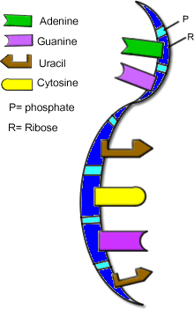
tRNA | Transfers each amino acid to the ribosome as it is specified by coded messages in mRNA | 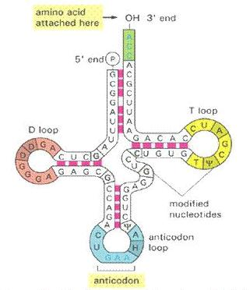
rRNA | Ribosomes are made of this type of RNA | 