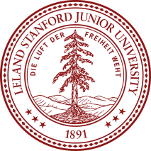
Stanford Science Penpals
Participation Permission Form

Stanford Science Penpals connects 6th-12th graders across the U.S to Stanford scientists. Our goal is to expose kids to diverse scientific careers, answer science questions, and share our love of science! Penpal exchanges start in September/October and end in May/June.

Students and Stanford scientists will not be in direct contact. Letters will be collected by your child’s teacher and sent to the Stanford Science Penpals leadership team. For safety, all letters sent/received will be screened by your child’s teacher and by the Stanford Science Penpal leadership team.

To learn more about our program visit https://www.stanfordsciencepenpals.com

Please return permission slip by __________________________

I give permission for my child, ____________________________________, to participate in Stanford Science Penpals’ penpal exchange program for the academic year of 2017 to 2018.

Print name: _____________________________________ Date: _________________________

Signature: _______________________________________

