Name: ______________________________________________________________________________________________ Period: ____________________
Starburst Energy

Ecological efficiency refers to the percentage of energy passed on from one organism to the next in a food chain or pyramid. In this activity you will use a model to discover the amount of energy lost as it moves up the food chain.

Procedures:
1. Your teacher will assign you to play an important part in the food chain. Stand where directed. Make sure you understand how many steps you are allowed to take.
- Producers take no steps (just like trees)
- Primary Consumers may take one step
- Secondary Consumers may take two steps
- Tertiary Consumers may take three steps
2. Make sure that you throw the candy over your shoulder and don’t look at where it is going.
3. Participate in the class discussion that takes place outdoors.
4. You may be asked to model the scenario again.
5. Record the data and answer the analysis questions.

Data:
Trophic Level | Round 1 | Round 2
Sun | 1
Producer | 16
1st Consumer | 8
2nd Consumer | 4
3rd Consumer | 2

Analysis:

1. What happened to the number of Starbursts (the energy) as they moved through the food chain?

2. To calculate the percentage of energy lost at each level, divide the energy that was available at the start (in this example, 20,126 Kcal) by the amount of energy on the level. In this example, the producer level has 100%, although you know that all the available sun energy has NOT been captured. The next level is calculated by dividing 1,996 by 20,126 and multiplying by 100. Using a calculator and rounding off, 10% of the energy remains on this level. Fill in the boxes for the 2nd and tertiary consumers: 100, 10,1,.1

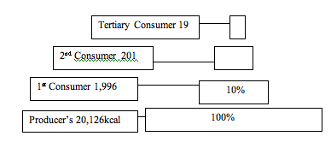

3. Calculate the percentage of energy transferred for our model in # of starbursts:

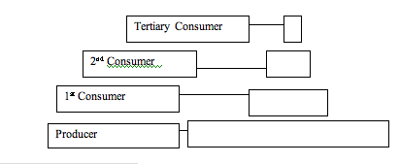
3. Why is the box at the base of the food pyramid larger than the top level?

- A huge portion of the energy in the world is lost. For example sunlight: only about 20% of the sunlight even makes it to plants and algae. Most of the energy from the sun is lost in space, reflected by clouds and water, or absorbed by the earth itself. How much energy is lost on average for the energy pyramids above?

- Explain how ninety percent of the energy is lost from a cow before it ever even reaches you.

As organisms die and decompose in the soil, their energy is not gone. For example, a dead tree can be cut and burned to produce heat, a different type of energy. Write three other example of dead organism providing energy long after it is gone.

1)_______________________________________________________________

2)_______________________________________________________________

3)_______________________________________________________________

- The starburst demonstration was a model of how an energy pyramid can work. Like all models it has weaknesses that make it unrealistic in some respects, name at least one.

Bonus: One kilocalorie is the amount of energy required to heat one kilogram of water by 1 degree Celsius. The regular human needs about 2,000kilocalories (Calories) to survive each day in a healthy manner. If we were able to transfer ten percent of our energy to heat water (instead of using it to live) how hot would a kilogram of water be at the end of the day?

