Station 1: Heart

- How are human hearts different from pig hearts?
- How are human hearts different from pig hearts?
- What do you notice about the tissues that make up the heart? Why is this significant?
- Find a valve. Describe it’s structure and explain how it relates to the function of valves.
- The aorta is the arched artery that carries oxygenated blood away from the heart. Describe it’s structure.
- Why do you think the aorta is arched?

Station 2: Eyes

l
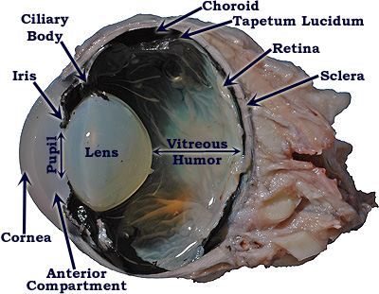

- Using the diagram above, see if you can identify as many structures as possible on the cow eyeball you have.
- Look at the cow eyeball, and the frog eyeball. What similarities do you notice?
- What differences do you notice? Other than size, obviously.
- Think of the needs of a cow vs. a frog. Why might the differences exist between the two eyeballs?
- Whose eyeball do you think a human’s would be closer to, and why?
- How are the two eyes examples of a homologous structure?
- Seeing color is a trait that evolved in mammals, but is not very developed in other phyla. Mammals see color using special cells on their retina – rods and cones. How do the retinas of a cow, human and frog compare?
  - Rods: black and white vision, work well in dim light
  - Cones: color vision, work best in bright light.
- What would be an advantage to color vision? What would be an advantage to non-color vision?
Station 3: Frog

Station 4: Shark

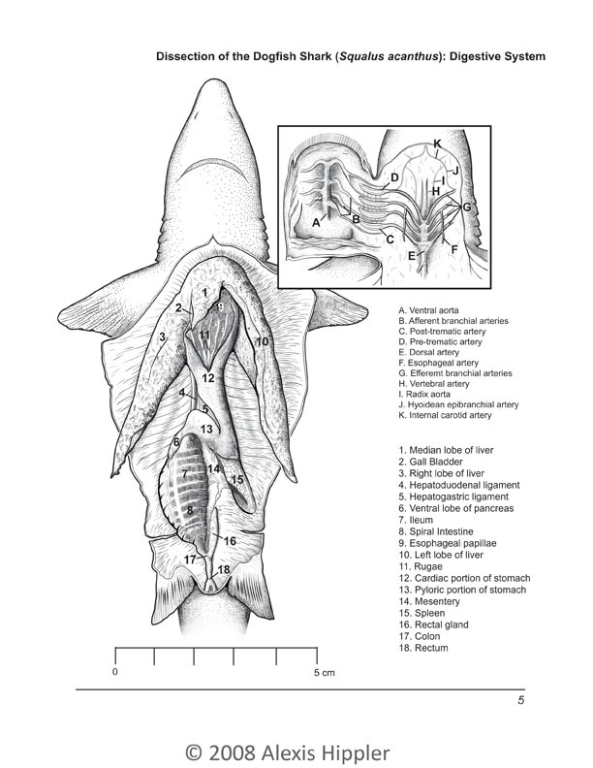
- Look at the specimen. Explore the insides! Write down at least 5 observations about the internal or external anatomy of the shark.
- Using the diagram above, see if you can identify at least 10 of the labeled anatomical structures.
- Sharks control their buoyancy using oil in their liver. How does the structure of the liver relate to this function?
- Is the shark male or female? How can you tell?

Station 5: Shark Babies/Eggs

- What do you think the white pouch attached to the fetal sharks is?
- If sharks have an umbilical cord, why don’t they have a belly button? Make a hypothesis.
- The dogfish shark has the longest gestation period of any invertebrate – 18 to 24 months. At birth they are usually 8-12 inches long. Based on the size of these shark pups, how long do you think this shark had been pregnant for?
- Think about how long the gestation period for these sharks is. What does that mean about their ability to evolve?
- Dogfish shark don’t reach sexual maturity until about 20 or 30 years old. What does that mean about the age of the shark at the previous station?

Station 6: Worms

- What is the difference between male worms and female worms?
- The vast majority of the internal anatomy of the worms is reproductive. How does this relate to what we learned in the evolution unit?
- What feature of the worms allows them to live in such different environments?
- The worms are a parasite that live in both pigs and humans. Based on what you know about symbiotic relationships; what does that mean about how it gets its food?
- Using your knowledge of the digestive system, where in the body would it make the most sense for the worms to live inside of a pig or human?
- Read the CDC fact sheet for the worms. How can you prevent infection?

Station 7: Brain

Human Brain:
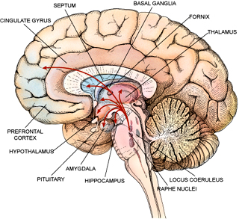
- Can you find all of the parts of a human brain on the sheep’s brain?
- What does this tell us about the brains of humans and sheep?
- What does it tell us about the evolutionary relationship between sheep and humans?
- The brain is divided into lobes – areas of the brain that are each in charge of a specific function. What is one way that scientists could have figured this out?
- Damage to which lobe(s) would interfere with learning new words??
- Damage to which lobe(s) would interfere with parking a car?
- Which lobe do you think Football players injure most? How does this affect them later in life?
- Think about modern day helmets. Are there any areas of the brain that they do not protect? Why do you think this is?
- Look at the lower portion of the brain. Pons is the Latin word for bridge. Why do you think this structure is called the Pons?
- Cerebellum is Latin for “little brain.” How does this structure resemble a little brain?
As illustrated in the human brain diagram below, there are two optic nerves that bring visual information from the eye to the brain. These nerves cross at the optic chiasm. The optic chiasm is an “X”-shaped structure where the two optic nerves, each of which originates in one of the eyes, partially cross. The crossing of the optic nerves that occurs at the chiasm, a phenomenon known as decussation, results in information from the right visual fields of both eyes being processed by the left hemisphere of the brain, and vice versa.
- Why do you think the olfactory bulbs in a sheep are larger (relatively) than a humans?
- Some Siamese cats have a genetic mutation where the wiring of the optic chiasm is disrupted. This cases a decrease in the crossing of the nerves. These cats are able to function normally, but have to alter their behavior to do this. How do you think they alter their behavior?
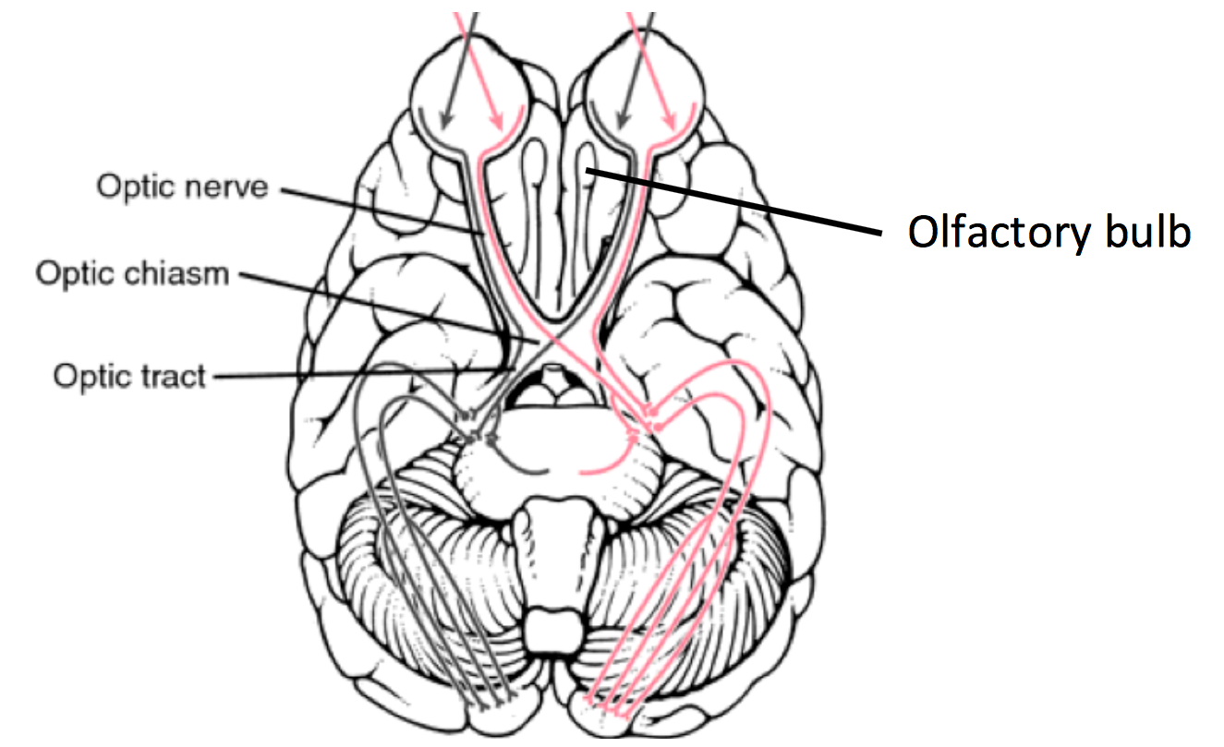
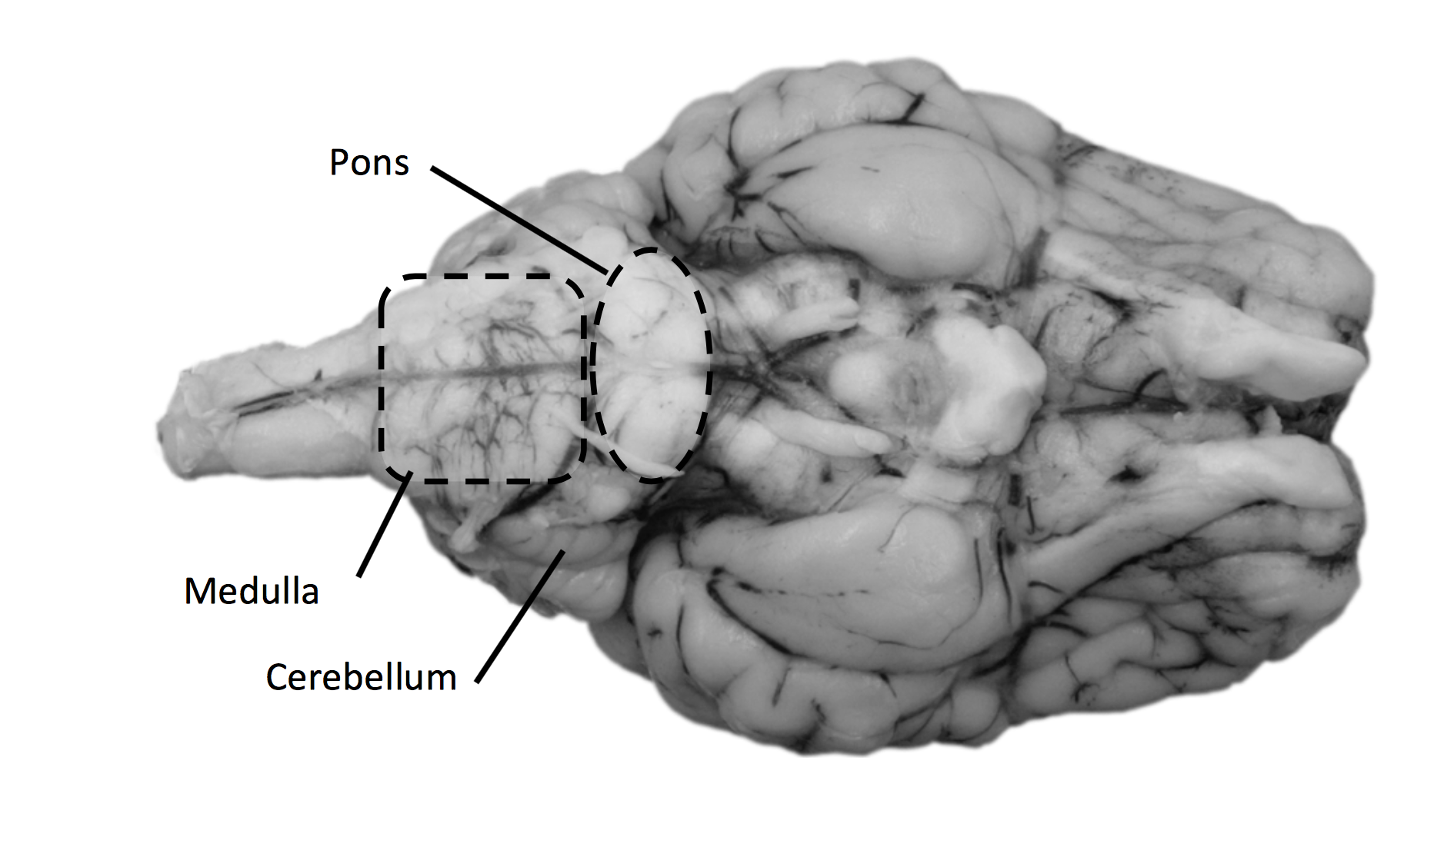
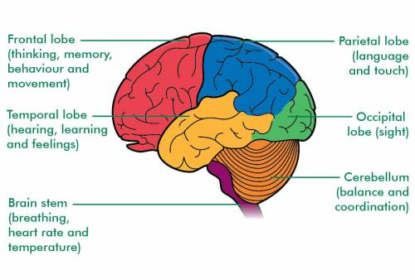

Station 8: Fetal Pigs
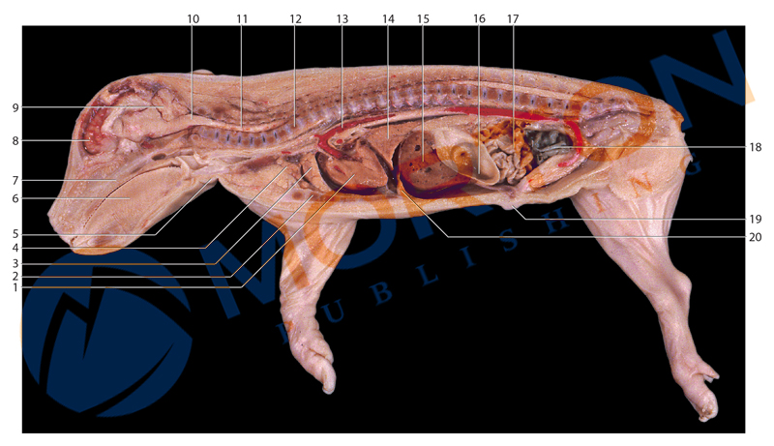
- On your paper, see if you can identify as many of the labeled organs above. The group with the most may get a prize! (no phones, duh)
Station 9: Octopus
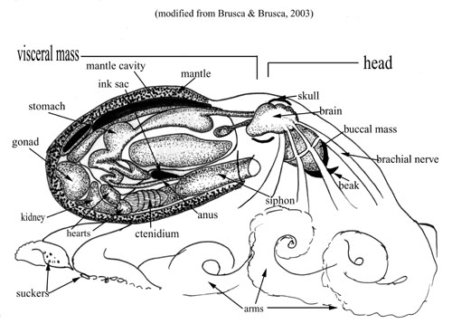

- See how much of the anatomy above you can identify on the specimen.
- Octopuses are classified in the Class Cephalopoda. In Latin, Cephalopd means “head foot.” How do you think these animals got their name?
- What other animals do you think are in the Class Cephalopoda?
- Many Cephalopoda evolved from marine animals that use a shell. How does the body shape of an Octopus support this?
- What would be an evolutionary advantage to losing the shell?
- Cephalopods are masters of camouflage – they can almost instantly blend in to any texture, coloring or shape. How does this ability relate to the loss of shell?
- Nautilus are Cephalopods that still have a shell. Do you think their ability to camouflage is as advanced as that of an octopus? Support your answer.

